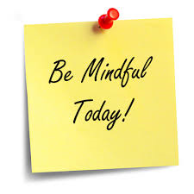
Mindfulness for Children

What is Mindfulness?
Mindfulness means becoming more aware of the present moment, with a sense of kindness and curiosity. This can help us enjoy the world around us more and understand ourselves better.

Mindfulness Meditation
Mindfulness meditation is a practice of mindfulness which involves:
- Sitting silently with your eyes closed
- Paying attention to thoughts, sounds, the sensations of breathing or parts of the body
- Bringing your attention back whenever the mind starts to wander
- Being kind to ourselves when things become difficult

This can be achieved with or without a supporting script which can be found on YouTube and Spotify. The Peace Out videos are great for children:
https://www.youtube.com/watch?v=9_vEZTrmtyA

Mindful Activities for Children:
A handful of activities you could try to start introducing mindfulness to children.

- Yoga poses – strong links to mindful practice can help children to notice sensations
- Mindfulness meditation/practice & body scan – sitting in a quiet place and focusing on breathing, physical sensations and noticing thoughts
- Mindful appreciation – noticing things within your day that usually go unappreciated – coming up with 5 things in that day
- Mindful Jars – glitter jars that are shaken up as you watch the glitter settler, take a mindful moment

- Mindful eating – Slowing down the experience of eating – breaking it down into difference senses – enjoying the moment!
- Mindful walks – Paying attention to our surroundings whilst on a family walk!

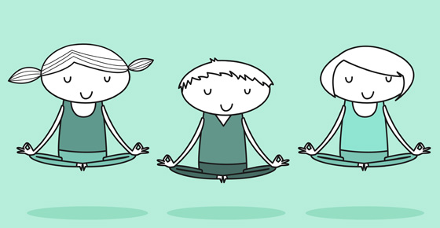

Applications to Introduce Mindfulness to Children

Available on iOS and Android phones and tablets

Dreamy Kids – Guided meditation and daily inspirational quotes (Free, in app purchases)

Super Stretch Yoga – An app for introducing Yoga to children (Free, in app purchases)

Head Space – Mindfulness scripts app – Tracks your progress (Free, in app purchases)


Stop. Think. Breath. (for children) – Mindful Meditation App & Emotional Check-In (Free, in app purchases)

Smiling Minds – Mindfulness Mediation App, developed by
educators (free, non-profit)

Websites with helpful information on Mindfulness

- https://www.nhs.uk/conditions/stress-anxiety-depression/mindfulness/?
- http://www.psychologyforchildren.com/
- https://positivepsychologyprogram.com/mindfulness-for-children-kids-activities/
- http://leftbrainbuddha.com/mindful-parenting-mindfulness-with-children
- https://www.mindful.org/meditation/mindfulness-getting-started/
- http://www.peacefulkids.com.au/meditations.html
- https://www.youtube.com/watch?v=-yJPcdiLEkI&safe=true (Mindfulness in Schools TED talk –Anne Marie Rossi)

